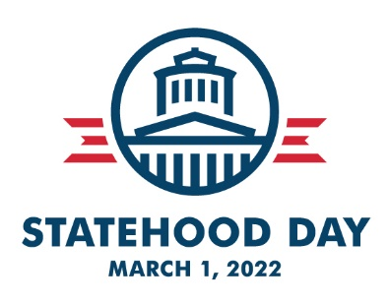

Statehood Day | Tuesday, March 1, 2022
Frequently Asked Questions

What is the significance of Ohio’s Statehood Day?
March 1, 1803 is one of the most important dates in Ohio’s history. Ohio’s constitution was approved by Congress in early 1803 and signed by President Thomas Jefferson on February 19. Ohio’s first elections had been held in January and the newly-elected Ohio General Assembly took up state business for the first time in Chillicothe on March 1, 1803.

Why attend the Statehood Day event?
Ohio’s “birthday” on March 1 is a most appropriate date to convene Ohio’s history advocates and organizations to advocate for history and historic preservation. Anyone passionate about Ohio’s history is encouraged to attend the annual event at the Ohio Statehouse and to schedule an appointment to meet with your state representative and state senator that same day. More information is available on the Statehood Day website to help you connect with your state elected officials. A briefing on the morning of March 1st will fill you in on some of the important issues affecting history and historic preservation in Ohio. The packet you pick up that morning will also provide plenty of information.

Who puts on the Statehood Day event?
Statehood Day is sponsored by Ohio History Connection, Heritage Ohio, the Ohio Archaeological Council, the Ohio Local History Alliance, the Ohio Travel Association, the Ohio Genealogical Society, the Ohio Museums Association, the Ohio Historical Records Advisory Board, Preservation Ohio, the Ohio Academy of History, Ohio Humanities, the Ohio Council for Social Studies and the Society of Ohio Archivists.
What is included in my registration?
When you register, you will get a name tag, a Statehood Day packet, light coffee and pastries, time for networking and the ability to be part of something larger – the opportunity to make a meaningful difference by expressing your support for Ohio history.

How should I prepare for the event?
First, don’t forget to register online as soon as possible. Seating is limited this year. Second, be on the lookout for e-mail announcements from the Ohio History Connection for any additional updates about the event. Schedule a time to meet with your state representative and senator on the day of the event, preferable in the afternoon. Most people dress for the event in business casual or professional attire. If they are unable to meet during this time, but earlier or later in the day, feel free to schedule your meeting then. Or meet with them back in your home district.

What should I know about parking and where to go when I arrive?
It is recommended you arrive as early as possible to secure parking for the event. The ideal parking option is at the Ohio Statehouse garage (which can be assessed through any of the four sides of the building (parking fee kiosks are on the Green level). Note: The garage typically fills up before 9 a.m. when the General Assembly is in session (which may be the case on March 1st). If the garage is full (signs will indicate this), there are several parking options nearby: Columbus Commons garage (formerly City Center garage), the Vern Riffe Center garage, or other surface lots in the area.

The recommended entrances to the Statehouse are through either the Statehouse parking garage or the 3rd Street entrance. Please allow for extra time to go through the security check area. Once inside, make your way to the Atrium, which is the large open room that connects the historic Statehouse building with the Senate Annex. Complimentary coat racks are available. Someone from the Ohio History Connection will be at registration to greet you.

How do I schedule a meeting with my state representative/state senator?
If you need to identify your representative/senator, use the link to the Ohio House members and Ohio Senate members on the Statehood Day website page. Call their office at least 2-3 weeks ahead of time to schedule an appointment for some time in the afternoon of March 1st if you are able. If they are unable to meet during this time, but earlier or later in the day, feel free to schedule your meeting then. Or meet with them back in your home district.

What else do I need to know?
A complimentary optional tour of the Ohio Statehouse will be given after the program concludes, around 1 p.m. No pre-registration is needed.

Additional information about the itinerary for the day including History Fund grant recipients, etc. will be provided to attendees the day of the event.

What if I have questions?
Additional questions may be directed to statehoodday@ohiohistory.org or by calling 877.393.4369.

